**Java Annotation**: Java Annotation is a tag that represents the *metadata* i.e. attached with class, interface, methods or fields to indicate some additional information which can be used by java compiler and JVM.

## **Built-In Java Annotations used in Java code**

* @Override(overiding parent method)
* @SuppressWarnings
* @Deprecated(his method is deprecated so compiler prints warning)

**Creating Your own annotation eg:**

| //meta notation  @Retention(RetentionPolicy.RUNTIME) //at what time this annotation is available  @Target(ElementType.TYPE)// class level  @interface SmartPhone  { String os() default "symbian" int version default 1  } // using annotation @SmartPhone(os="android" version=6) public class NokiaPhone{  String model;  int size;  public NokiaPhone(String model ,int size)  {  this.size=size;  this.model=model;  }  public class AnnotationDemo{  public static void main(String args[])  {  NokiaPhone obj= new NokiaPhone("Fire", 5);  class c=obj.getClass();// method of obj class, return runtime class of object  Annotation an=c.getAnnotation(SmartPhone.class);  Smartphone s=SmartPhone(an);  System.out.println(s.os());  }  }  // output : android |
| --- |

**Dependency Injection:**

**Spring**: Dependency injection framework

**Spring Boot**

* Inbuilt configurationIt has taken all XmlBaseConfiguration and provided annotation

for using Spring framework.

* integrate server for development(Tomcat)
* Error handling mechanism scloud configuration
* devtools(no need to restart app)

**SpringbootApplication** Annotation contains

SpringbootConfiguration, EnableAutoConfiguration, ComponentScan.

**application.properties** : configuration file- changing port, debug, configuring view resolver(to map jsp pages)

| logging.level.org.springframework.web: DEBUG // help to debug specific application |
| --- |

**group id** is very similar to package and **artifact id** is similar to class

**@Controller** : help us to pick up class for mapping in spring boot

**@RequestMapping**: help to pick method

***DispatcherServlet*** receives all of the HTTP requests and delegates them to controller classes. and start looking from view through return statement of controller class

@ResponseBody: help to prevent dispatcher servlet to find view instead return the statement as response

**Spring boot starter parent**

provide default plugin, default dependencies, default java version

Spring boot starter web:

all dependencies to run web app (validation, login embedded tomcat, embedded spring webmvc etc)

**JSP** technology is used to create web application just like Servlet technology. It can be thought of as an extension to Servlet because it provides more functionality than servlet such as expression language, JSTL, etc.

A JSP page consists of HTML tags and JSP tags

The **@RequestParam** is used to read the HTML form data provided by a user and bind it to the request parameter.

when we pass data from controller to view then it put data in **model** and the used by view

**USE OF DISPATCHER SERVLET(FRONT CONTROLLER)**

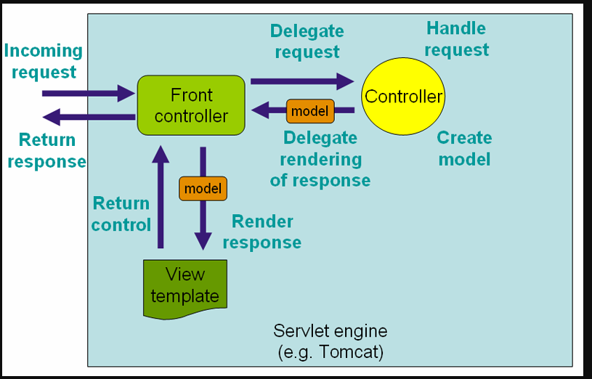

Spring boot **AutoConfiguration** auto configure dispatcher servlet

The **@Component** annotation is used to load a java class as a bean. All classes with annotation such as @Component, @bean etc are auto-wired in the spring boot application.

The **@autowired annotation** is used to inject dependency. Dependency injection is done in two ways, by name and by type. @Autowired by type uses the class type to auto wire the spring boot bean class

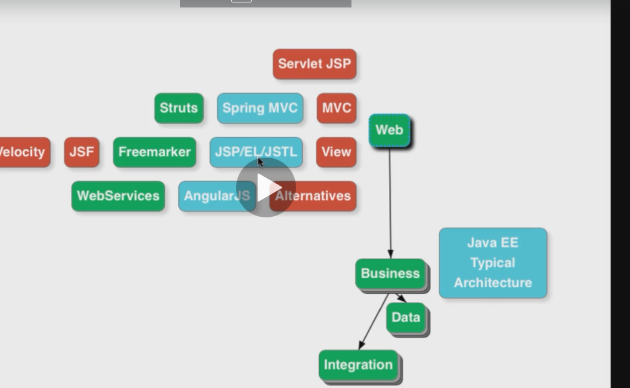

**Web Architecture**

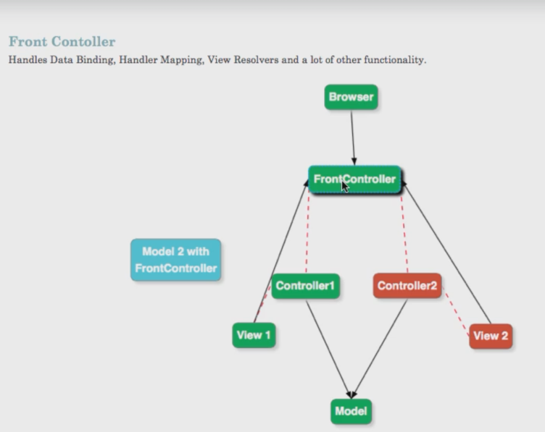

**Session** : way to store value across multiple requests(views).

**@SessionAttribute** Annotation help in this.